1. **Purpose and Scope**

The purpose of this SOP is to provide direction on how to fill in Demersal and Pelagic sampling forms which are used to form part of the data required to comply with the DCMAP. This SOP is aimed at all analysts who carry out biological sampling events

1. **Responsibility**
   1. It is the responsibility of Senior Laboratory Analyst to ensure that staff are trained and compliant with this SOP.
   2. It is the responsibility of all personnel involved to comply with relevant SOPs.
   3. It is the responsibility of all personnel to notify Senior Laboratory Analyst if any difficulties are experienced while following SOP guidelines.

1. **Definitions / Terminology**

* FEAS – Fisheries Ecosystems Advisory Services
* SOP – Standard Operating Procedure
* DCMAP – Data Collection Multi Annual Programme

1. **Health and Safety**

This SOP details an administrative procedure therefore no health and safety precautions are listed here. General health and safety policies of the Marine Institute Safety Statement must be adhered to at all times (available on the intranet).

1. **Procedure**

* 1. This procedure refers to the following sampling forms within P3

FEAS- F006_ Age sampling data sheet Dem-Pel 1cm

FEAS- F00x_ Age sampling data sheet Dem-Pel half cm

FEAS- F007_Demersal length sampling datasheet

FEAS- F008_Tuna measured weight sampling data sheet

FEAS- F009 _Demersal length sampling datasheet sexed species

FEAS- F010_Demersal multi species length only

* 1. Definitions for all Form Headers

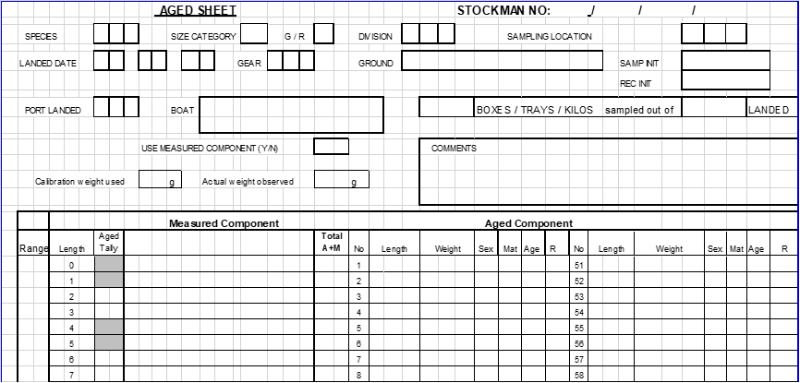

Figure 1 Typical headers used in most sampling sheets

|  |  |
| --- | --- |
| **HEADER** | **DESCRIPTION** |
| **Species** | Fish species being sampled.  Three letter code *Appendix 1- Table 1 Lists of codes* |
| **Size Category** | Fish can be U = Unsorted /Ungraded or sorted into S = Small, M = Medium, L = Large. Some species like Hake can be graded by numbers 1,2,3,4,5 |
| **G/R** | Fish presentation- G-Gutted, R-Round (whole). |
| **Division** | ICES Area/Division where the sample was caught. *  Appendix 1- Figure 2 |
| **Sample Location** | Where sampling event took place *  Three letter code *Appendix 1- Table 1 Lists of codes* |
| **Landed Date** | Date of when the landed event took place |
| **Gear** | Gear used to catch sample*  Three letter code *Appendix 1- Table 1 Lists of codes* |
| **Ground** | The fishing ground on which the sample was caught. Refer to local name given by the fishermen. If this is not possible or the ground name given is dubious, write ‘unknown’ *Appendix 1- Figure 2* and in Stockman  ICES rectangle if known |
| **Sampler Init** | Initials of sampling person |
| **Rec Init** | Initial of data recording person |
| **Landed** | Location where sample was landed.  Three letter code *Appendix 1- Table 1 Lists of codes* |
| **Boat** | Boat that caught the sample. The name of the boat can often be found on a label in/on the side of the fish box.**\*** |
| **Use Measured Component (Y/N)** | Tick this box “Y” if the sample can be used as a measured sample also.  A sample may be used for measure only data if:   * Sample is ungraded * Sample is graded and sampling is representative across **all** of the grades landed * Only one grade of a species is landed for the boat, e.g. large plaice |
| **X boxes/trays/kg sampled out of X Landed** | Number of boxes/trays/kgs sampled from the total number of boxes/trays/kgs landed. |
| **Comments** | Any additional comments or information |
| **Calibration Weight Used (g)** | Weight of calibration used |
| **Actual Weight Observed** | Weight observed for calibration weight in grams |
| **STOCKMAN No:** | To be completed upon logging sample into stockman data base |
| **AGE Component** | |
| **Range** | The Size Range of fish present in the sample i.e. if the fish start in the 30’s put a three in the first area and then 4 in the next to indicate 40’s |
| **Length** | This column indicated the length size coupled with the range |
| **Age Tally** | A stroke is recorded under Aged Tally if an ageing structure has been collected for that length. The strokes are built up into blocks of five to facilitate easy counting and can be presented in either of the following ways: |
| **Measured Component** | A stroke is recorded under Measured Component if the fish has been measured but an ageing structure has not been collected for that length |
| **Total A+M** | The combined total number fish recorded at that length |
| **No:** | This number corresponds to the cell of an otolith box where each otolith should be correctly stored for any length/weight recorded |
| **Length/**  **weight/ sex/mat** | Length of fish recorded in cm, Weight recorded in grams. Sex and/or Maturity should be recorded for all Flatfish |
| **Age** | Age of fish assigned by age readers |
| **R** | Readability of the age attributed by the age reader |

* 1. Filling in form correctly
     1. All information recorded should be legible and neatly presented, using a pencil.
     2. Data sheets should be kept as clean as possible.
     3. Refer to FEAS-SOP-022 Demersal Sampling Design, and Pelagic Sampling Protocol SOP (currently in draft) for Otolith collection per species, per size class.

Appendix 1

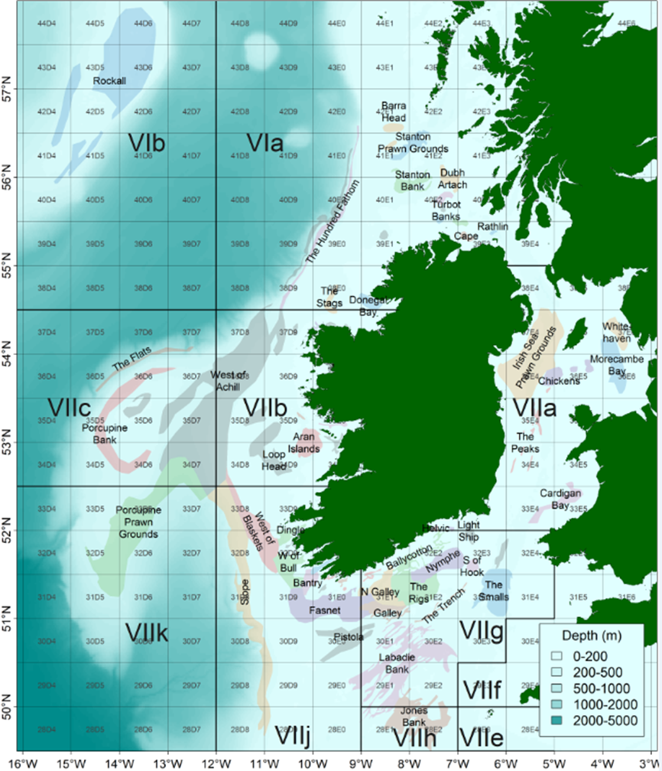

Figure 2. ICES Areas & Rectangles with names of common fishing grounds.

Table 1: Lists of Codes

|  |  |  |  |  |
| --- | --- | --- | --- | --- |
| **Species** | **Code** |  | **Fishing Gear** | **Code** |
| Black Sole | SOL |  | Beam Trawl | TBB |
| Blonde Ray | BLR |  | Bottom Otter Trawl | OTB |
| Budegassa (Black Anglerfish) | BUD |  | Gillnet | GN |
| Cod | COD |  | Pair Trawl Mid-water | PTM |
| Cuckoo Ray | CUR |  | Scottish Seine | SSC |
| Haddock | HAD |  | Single Trawl Mid-water | STM |
| Hake | HKE |  | Twin Rig Otter Trawl | TWR |
| Lemon Sole | LEM |  |  |  |
| Megrim | MEG |  |  |  |
| Piscatorius (White Anglerfish) | PIS |  |  |  |
| Pollack | POL |  |  |  |
| Plaice | PLE |  |  |  |
| Saithe | POK |  |  |  |
| Sandy Ray | SAR |  |  |  |
| Spotted Ray | SDR |  |  |  |
| Spurdog | SPR |  |  |  |
| Starry Ray | SYR |  |  |  |
| Thornback Ray | THR |  |  |  |
| Whiting | WHG |  |  |  |
| Witch | WIT |  |  |  |
| Herring | HER |  |  |  |
| Mackerel | MAC |  |  |  |
| Horse Mackerel/Scad | HOM |  |  |  |
| Boarfish | BOF |  |  |  |
| Blue Whiting | WHB |  |  |  |
| Atlantic Bluefin Tuna | BFT |  |  |  |
| Tuna | TUN |  |  |  |

|  |  |
| --- | --- |
| **Sampling Location** | **Code** |
| Atlantic Dawn Ltd | ATD |
| Ballycotton Seafoods | BCN |
| Castletownbere Co-op | CTC |
| Clogherhead Fisherman's Co-op | CFC |
| Dublin Fish market | DFM |
| Kingfisher Fresh | KFF |
| Foyle Fisherman's Co-op | FFC |
| Gallagher Bros | GAL |
| Galway and Aran Fisherman's Co-op | GAC |
| Island Seafood | OSF |
| Killybegs Seafoods | KSF |
| Kerry Fish Ltd | KFL |
| Malin Seafoods | MAS |
| Norfish | NOR |
| Normandy Fish Schull | OCH |
| North Cape Seafood’s | NCS |
| O' Cathains Processors | OMH |
| Oceanpath Processors | OCP |
| Paulona | PNA |
| Premier Fish Products | PFP |
| Saltees Kilmore Quay | SKQ |
| Unionhall Fisherman's Co-op | UFC |
| Wards Ltd | WAR |

|  |  |
| --- | --- |
| **Landing Location** | **Code** |
| Arklow | ARK |
| Balbriggan | BAL |
| Ballinskelligs | BSK |
| Ballycotton | BCT |
| Ballydavid | BDV |
| Baltimore | BMR |
| Burtonport | BUR |
| Castletownbere | CTB |
| Clogherhead | CLO |
| Cobh | COB |
| Courtmacsherry | CMY |
| Dingle | DIN |
| Downings | DOW |
| Drogheda | DRO |
| Dun Laoghaire | DLA |
| Duncannon | DUN |
| Dunmore Est | DMR |
| Greencastle | GRE |
| Greystones | GST |
| Helvic | HEL |
| Howth | HOW |
| Killybegs | KBG |
| Kilmore Quay | KMR |
| Kinsale | KIN |
| Portmagee | PMG |
| Rathmullan | RTM |
| Renard | REN |
| Ros an Mhíl | ROS |
| Rosslare | RSE |
| Schull | SCH |
| Skerries | SKE |
| Union Hall | UNH |
| Waterford | WFD |
| Wexford | WXD |
| Wicklow | WIC |